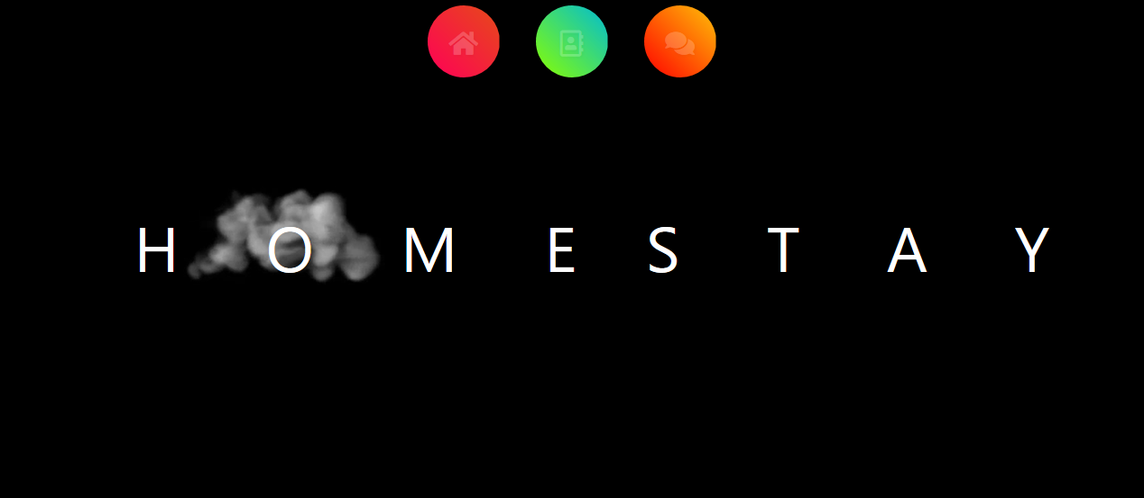

On clicking About us icon it will show about us page..

